**This guide is only for those users who have already received their VPN account information such vpn login and Activation code**

**1 Download the app (only if you haven’t installed it before)** please ensure in advance that the time and date settings (time, date and time zone) on your iPhone are correct. Download the app using the **App Store on IPhone** and **Play store on Android phones** or **Microsoft Store on Windows phone** and searching for “RSA SecurID”.



**2 Check your activation code** you should have received an activation code from the person who ordered your token or in an email from SIMA (or in your resolved ticket). Please contact him/her, if you have not received it yet. Otherwise create your ticket in ServiceNow to request a VPN account (Home…Catalog…Remote Access VPN). If you missed your email or did not use your Activation Code within 7 days, you will need to make another ticket and start over.

**3 Input activation code and URL** Open the RSA app and accept the license agreement if asked. Select the QR symbol on the bottom left and accept the usage of your camera. Scan the QR code and enter your activation code.

** **

**QR Code for IPhone QR Code for Android Phone**

** QR Code for windows phone**

**4 (Critical)**: Please verify that the Activation code for RSA App which is sent to user is matching with phone model that users have. If the **RSA Activation code** is ordered for a different phone mode than actual phone that users have, it will not work. (For **e.g. VPN/Activation code ordered for Android or windows phone but user has IPhone**.)

**5 Open** below link (Copy and Paste into browser)

<https://alps.allianz-assistance.com/token>

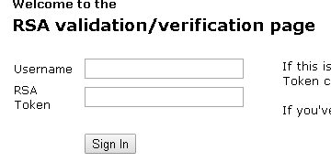

**6** You will see above screen.

**7** Your user name will be your **full email** or in some cases your **windows login ID** (Try one or the other). Take note of the case sensitivity that you enter and continue to use that in your future VPN connections.

**8 Enter** your RSA code (see the 6 digits of your RSA token on your phone). Click on Sign in, you will then be asked to enter a PIN (please create a new pin using combination of 4 numbers which is easy for you to remember). Cannot begin with a zero.

**9 Re-authenticate**/Sign in again using PIN followed by the Token code. For e.g. my pin is 2233 and RSA Token is 456789, I have to enter 2233456789

**10** From this point, your RSA Token/ Password is always Pin+Token code. (Only for VPN)